To design and develop a robot car that capable of delivering items within campus

Mr.VIRUPAKSHA GOUDA, Mohammed Ali, Mandeep Singh, Mohammed Irshaq and Aishwarya V *Department of Computing Science*

*Ballari Institute of Technology and Management, Ballari*

mohammedalibitm@gmail.com

***Abstract—***The "Delivery Robot" research project introduces an autonomous robotic system designed for efficient package delivery. Utilizing HC-SR04 ultrasonic sensors, IR sensors, and Bluetooth technology, the robot achieves obstacle detection, avoidance, and wireless communication. Key components, including Arduino Uno, motor drivers, wheels, and a camera with audio features, form a robust hardware foundation.

In this paper, Intelligent control system development, orchestrating sensor inputs and wireless communication for seamless navigation and autonomous delivery operations. Equipped with a carrier box, the robot can securely transport packages and make decisions based on environmental inputs.

Incorporating an IR receiver allows for remote control, providing a hybrid manual control option for users. This research contributes valuable insights to the robotics field, addressing challenges in autonomous navigation and package delivery. The modular design offers scalability and adaptability to diverse environments, laying the groundwork for future advancements in automated delivery systems.

***key words* —** Autonomous Robot, Package Delivery,

HC-SR04 Ultrasonic Sensors, IR Sensors.

**INTRODUCTION**

In the intricate tapestry of modern logistics, the development of an autonomous delivery robot tailored for campus environments represents a bold step towards redefining the very fabric of package transportation. This endeavor converges an impressive array of cutting-edge technologies, from the precise control offered by HC-SR04 ultrasonic sensors to the nuanced detection capabilities of IR sensors, all orchestrated seamlessly through the Arduino Uno microcontroller. At its core, this project embodies a vision of efficiency, convenience, and reliability in the delivery process. Yet, its significance transcends mere functionality; it epitomizes a paradigm shift in how we conceive of and interact with delivery systems. With a camera equipped with audio capabilities, the robot becomes not just a tool for transportation, but a dynamic intermediary, fostering real-time communication and transparency between sender and recipient. Meanwhile, the inclusion of a sturdy carrier box underscores a commitment to package security, ensuring that items arrive safely and intact. However, perhaps the most remarkable aspect lies in the project's adaptability and foresight. Through its modular design and integration of intelligent control systems, the robot becomes more than a mere machine—it becomes a platform for innovation.

It can navigate intricate pathways with ease, adapting its route on-the-fly to circumvent obstacles and optimize efficiency. Moreover, its scalability ensures that it remains relevant in an ever-evolving landscape of technological progress. In essence, this project isn't just about creating a delivery robot; it's about reshaping the very contours of logistics itself. By seamlessly blending cutting-edge technology with practical utility, it sets a new standard for efficiency, reliability, and user experience in package transportation. And as it paves the way for a future where autonomous systems play an increasingly central role in our daily lives, it reminds us of the transformative power of innovation and human ingenuity. Moreover, beyond its immediate applications within campus environments, the implications of this project extend far and wide. It serves as a beacon of inspiration for industries grappling with the challenges of last-mile delivery, offering a glimpse into a future where efficiency and sustainability go hand in hand. Moreover, it underscores the crucial role of collaboration and interdisciplinary thinking in driving meaningful change. Through partnerships between engineers, designers, and stakeholders, this project exemplifies the power of collective ingenuity in tackling complex real-world problems. Furthermore, the ripple effects of this project are felt not only in the realm of logistics but also in broader conversations surrounding automation, artificial intelligence, and the future of work. As autonomous technologies continue to proliferate, questions arise about their impact on employment, safety, and societal norms. This project serves as a microcosm of these larger discussions, prompting us to consider the ethical and social implications of a world increasingly governed by machines.

This research paper aspires The design and development of a cost effective autonomous mobile robot prototype have been presented that can deliver packages safely to a desired destination using Global Positioning System (GPS). The robot ensures a secure and human-contactless delivery by using a password protected container to carry the delivery package. The four wheel drive robot can successfully navigate to a preset location by receiving GPS coordinates from satellites and correcting its direction using a digital compass.

The development of an autonomous delivery robot tailored for campus environments is more than just a technological feat; it's a testament to human ingenuity, collaboration, and the relentless pursuit of progress. As it navigates the complex terrain of modern logistics, this project reminds us that the future is not something to be passively awaited, but actively created. And in embracing the challenges and opportunities that lie ahead, we pave the way for a future that is not just smarter and more efficient, but also more humane and inclusive.

**RELATED WORK**

Mario Sarcinelli-Filho et al.(2021) introduced A Path-Following Controller for a UAV-UGV Formation Performing the Final Step of Last-Mile-Delivery UAV to land on a UGV, its reference base, after completing a delivery. A high-level controller, guided by a virtual structure paradigm, directs this formation. An obstacle avoidance algorithm is integrated to address potential structions. Simulated and experimental results validate the effectiveness of the proposed controller.

Daegyu Lee et al.(2021) introduces a robot system designed to help postal workers carry heavy packages in busy urban areas like apartment complexes. Since GPS signals can be unreliable there, we use a 3-D point cloud map for accurate positioning and a visual system to navigate. The robot can communicate with a control center, allowing the operator to monitor its progress and stop it if needed. Postal workers can choose between letting the robot drive itself or following them using their phone. We tested the system with real postal workers over four weeks and found it works well, navigating accurately and avoiding obstacles.

Wanpeng Zhang et al.(2020) introduces With the rise of online shopping and fast delivery, unmanned ground vehicles (UGVs) and aerial drones (UAVs) are teaming up for different jobs. They've been used in tough military tasks like checking out cities in conflict, patrolling borders, and helping after disasters. They're also handy in civilian tasks like gathering data, finding illegal buildings, and making maps. During health crises like COVID-19, getting packages safely without contact is important. UGVs and UAVs working together could be a good solution for safe delivery. Kurniawan et al. (2018) implemented Augmented Reality (AR) for tourist guidance on Batam Island in their study, "Object Visualization Using Maps Marker Based On Augmented Reality." Utilizing Unity and Vuforia, the AR app displays 3D objects on a map for real-time navigation. Testing validated the effectiveness of AR for interactive and location- based tourist experiences.

Taejin Kim et al(2024) introduces robots delivering stuff indoors have become popular, but going up and down multiple floors is tough for them. So, we ade a special robot just for indoor delivery. It's got five main parts: map, location, path, eyes, and planning. By combining different maps, our robot knows where to go and even how to use elevators. We tested it in a regular building for a month, and it did great. Our study shows how robots can deliver on their own, with smart maps, and handle real-life situations well.

**PROPOSED WORK**

This project introduces an Arduino-based smart robot car designed for the delivery of files or documents in diverse environments. The smart car offers two distinct operational modes: Line Following and Remote Control, combining with Obstacle Avoidance to create a multifunctional and adaptable platform for streamlined delivery tasks. For manual control and flexibility, the Remote Control mode allows users to navigate the delivery car using a mobile phone as a remote controller through WiFi connectivity. This enables human intervention when necessary, especially in situations requiring fine-tuned adjustments or human judgment. This feature is particularly beneficial when the vehicle needs to interact with a human operator or be directed remotely. Obstacle Avoidance mode equips the delivery car with sensors to detect and navigate around obstacles in real-time. This capability ensures the safety and efficiency of the delivery process, especially when dealing with the unforeseen obstructions or dynamic environments.

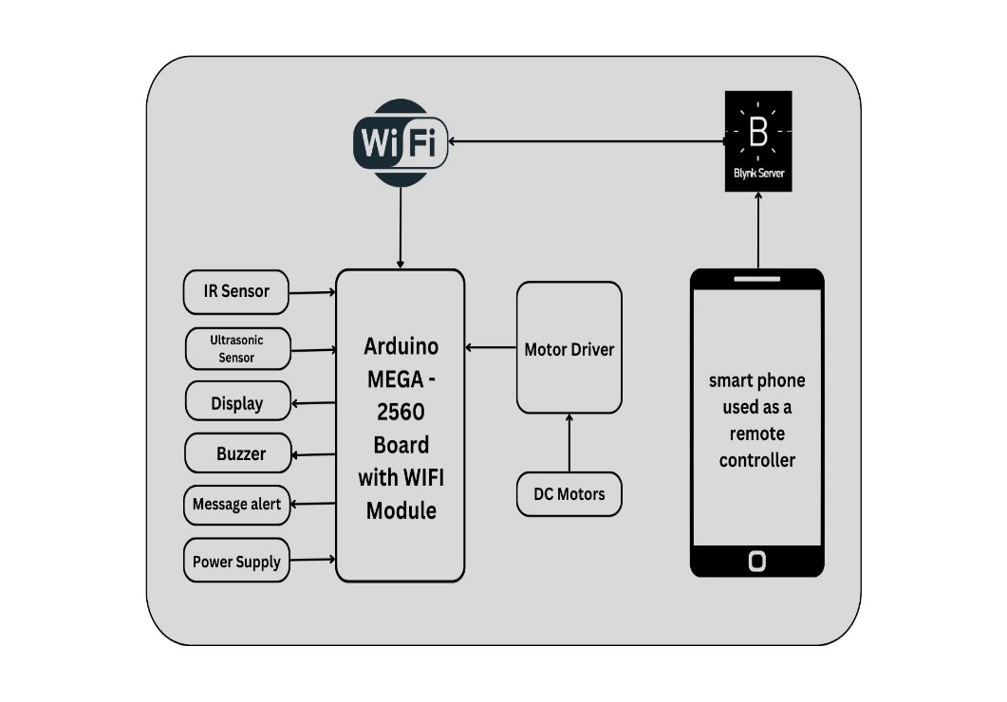

Fig-1: Block diagram of proposed system.

# Blynk Platform:

In the development of our project, we have opted for Blynk

Platform. it is a IoT platform that empowers users to create custom mobile applications for controlling and monitoring connected devices remotely. It provides a user-friendly interface and a robust infrastructure for building IoT projects without the need for extensive programming knowledge or hardware expertise.

At the core of the Blynk platform is its mobile app, available for both iOS and Android devices. The app allows users to design intuitive and interactive control interfaces, known as "widgets," using a drag-and-drop interface. These widgets can include buttons, sliders, gauges, graphs, and more, providing users with a customizable way to interact with their IoT devices.

Blynk supports a wide range of popular development boards and microcontrollers, including Arduino, Raspberry Pi, ESP8266, and ESP32, among others. Users can easily connect their hardware to the Blynk platform using the Blynk-provided libraries and APIs, enabling seamless communication between their devices and the Blynk cloud server.

One of the key features of Blynk is its cloud-based infrastructure, which facilitates real-time communication between the user's mobile app and their connected devices. This allows for instant feedback and control, regardless of the user's location, as long as they have an internet connection.

# Blynk Server:

Blynk servers form the backbone of the Blynk platform, providing the infrastructure necessary to enable communication between IoT devices and the Blynk mobile app. These servers play a crucial role in facilitating the seamless exchange of data and commands, allowing users to remotely monitor and control their connected devices from anywhere with an internet connection.

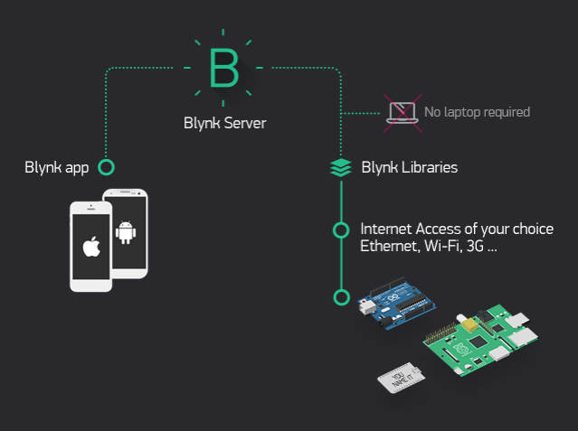Blynk servers provide a reliable and secure infrastructure for building and deploying IoT projects, empowering users to create connected devices and applications with ease. Whether for home automation, industrial monitoring, or smart agriculture, Blynk servers enable seamless communication and control of IoT devices, driving innovation and efficiency in various domains.

Fig-2: Rating of images based on their features

**key features:**

The smart delivery car boasts interaction features like cameras and speakers for seamless communication between delivery personnel and recipients during goods exchange.

Equipped with autonomous navigation capabilities, it follows predefined paths, minimizing the need for human intervention during delivery. Its modular design allows for easy maintenance, repair, and upgrades, ensuring longevity and sustainability. Additionally, customization options enable hardware and software adjustments to meet specific delivery requirements or preferences. With Line Following mode, the car autonomously navigates predefined paths, optimizing efficiency by reducing manual control. Real-time navigation ensures timely and accurate delivery of goods, whether autonomous or manually controlled.

# Case Studies:

Line Detection Mechanism:

The line following robot car employs infrared (IR) sensors to implement its sophisticated detection mechanism. These sensors utilize advanced detection algorithms to precisely identify the presence of a black line on the ground, enabling the robot to follow the path accurately. The IR sensors continuously scan the surface beneath the car, detecting changes in surface color or reflectivity. Once a black line is detected, the sensors trigger the appropriate control signals to steer the car along the line's path in real-time. This mechanism ensures precise navigation and smooth movement of the robot car along the designated route..

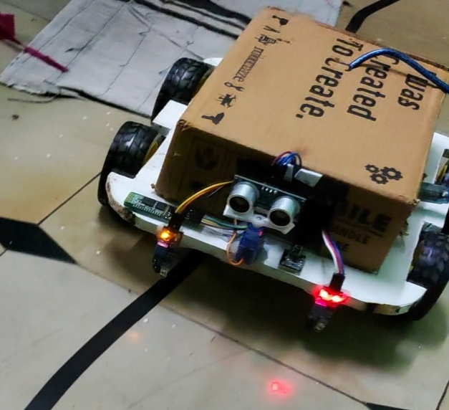

Fig-3: Line Detection Mechanism

Obstacles Detection Mechanism:

The line following robot car incorporates ultrasonic sensors to implement its obstacle detection mechanism. These sensors utilize ultrasonic waves to detect the presence of obstacles in the car's path, enabling it to navigate safely in dynamic environments. The ultrasonic sensors emit high-frequency sound waves and measure the time it takes for the waves to bounce back after hitting an obstacle. By analyzing the time delay between emission and reception, the sensors can determine the distance to the obstacle with high accuracy. When an obstacle is detected within a predefined range, the sensors trigger the appropriate control signals to steer the car away from the obstacle, ensuring collision avoidance. This mechanism enables the robot car to navigate effectively and avoid potential hazards in its surroundings.

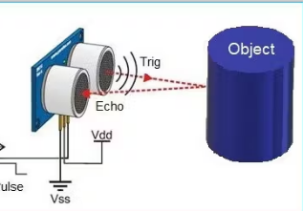

Fig-4: Obstacles Detection Mechanism

**CONCLUSION**

In conclusion, this project introduces an Arduino-based smart robot car, purposefully engineered for the efficient delivery of files or documents across diverse environments. Through its integration of two operational modes - Line Following and Remote Control - augmented by Obstacle Avoidance, the system offers a versatile and adaptable solution for optimized delivery tasks. The Remote Control mode, leveraging WiFi connectivity with a mobile phone, facilitates manual intervention when precision adjustments and human judgment are imperative, particularly in intricate scenarios. Concurrently, the Obstacle Avoidance mode, equipped with sensors, ensures the vehicle's safety and efficacy by swiftly detecting and circumventing obstacles in real-time. Collectively, this smart car represents a significant stride in automated delivery systems, embodying a harmonious blend of technological ingenuity and pragmatic functionality to address the evolving demands of contemporary delivery logistics.

**REFERENCES**

1. An Autonomous Vehicle for Parcel Delivery in Urban Areas” Alexander Buchegger, Konstantin Lassnig, Stefan Loigge, Clemens Muhlbacher, and Gerald Steinbauer, 2018 21st International Conference on Intelligent Transportation Systems (ITSC)Maui,Hawaii, USA.
2. Design and Development of Autonomous Delivery Robot” Aniket Gujarathi, Akshay Kulkarni, Unmesh Patil, Yogesh Phalak, Rajeshree Deotalu, Aman Jain, Navid Panchi under the guidance of Dr. Ashwin Dhabale and Dr. Shital S. Chiddarwar-2020.
3. Object Recognition of Outdoor Environment by Segmented Regions for Robot Navigation” Dae-Nyeon Kim, Hoang-Hon Trinh, and Kang-Hyun Jo, Graduate School of ElectricalEngineering, University of Ulsan-2019.
4. An Autonomous Delivery Robot to Prevent the Spread of Coronavirus in Product Delivery System” Murad Mehrab Abrar, Raian Islam, Md. Abid Hasan Shanto, Ahsanullah University of Science and Technology-2021
5. Delivery Robots in Logistics: A Review of Recent Advances and Challenges" by Nalinaksh Vyas and Arindam Ghosh. (2021)
6. Design and Development of a Low-cost Autonomous Delivery Robot for Indoor Environments" by Fernando Sancho, Andrés Olivares, and Luis Payá. (2018).
7. Delivery Robots for Last-mile Logistics Operations: A Review" by Vikas Kumar, Luciana Moreira, and Johan Scholliers. (2019)
8. A Comprehensive Study on the Application of Drones in Logistics and Supply Chain Management" by Kunpeng Zhang, Yuan Li, and Jiang Zhang. (2020).
9. A Review on the Use of Autonomous Unmanned Aerial Vehicles for Delivery Services" by Nanda Kumar D, Hanumanthappa M, and Vijaya Kumar B P. (2019)
10. Website: Starship Technologies - https://www.starship.xyz/ YouTube: Starship Autonomous Delivery Robots - <https://www.youtube.com/watch?v=RcP_e7nNTgk>
11. Website: KiwiBot - https://www.kiwibot.com/ YouTube: KiwiBot Food Delivery - <https://www.youtube.com/watch?v=ZvQgEaCTsN4>
12. Website: Robby Technologies - https://robby.io/ YouTube: Robby Delivery Robot - <https://www.youtube.com/watch?v=blLl2zHlNRI>
13. Website: Marble - https://www.marble.io/ YouTube: Marble Delivery Robots - https://www.youtube.com/watch?v=X6XtpStAT8U